TEZ ŞABLONU AÇIKLAMA FORMU
THESIS TEMPLATE EXPLANATION FORM.
- Şablonda belirtilen boşluklar ve yerleşim düzeni sabit kalmalıdır. |  |  | - Spacing and placement in the template must not be changed.
- Jüri tarihi Başlık Sayfası, İmza Sayfası, Abstract ve Öz’de ilgili yerlere yazılmalıdır. |  |  | - Write defense date to the related places given on Title page, Approval page, Abstract and Öz.
- Jüri üyelerinin unvanları imza sayfasına doğru girilmelidir. |  |  | - The titles of the examining committee members must be correctly expressed on the Approval Page.
- Tezin son sayfasının sayfa numarası Abstract ve Öz’de ilgili yerlere yazılmalıdır. |  |  | - Write the page number of the last page in the related places given on Abstract and Öz pages.
- Bütün bölümler, referanslar, ekler ve CV sağ sayfada başlamalıdır. Bunun için kesmeler kullanılmıştır. Kesmelerin kayması fazladan boş sayfaların oluşmasına sebep olabilir. Bu gibi durumlarda paragraf (¶) işaretine tıklayarak kesmeleri görünür hale getirin ve yerlerini kontrol edin. |  |  | - All chapters, references, appendices and CV must be started on the right page. Section Breaks were used for this. Change in the placement of section breaks can result in extra blank pages. In such cases, make the section breaks visible by clicking paragraph (¶) mark and check their position.
- Figürler ve tablolar kenar boşluklarına taşmamalıdır. |  |  | - All figures and tables must be given inside the page. Nothing must appear in the margins.
- Şablonda yorum olarak eklenen uyarılar dikkatle okunmalı ve uygulanmalıdır. |  |  | - All the warnings given on the comments section through the thesis template must be read and applied.
- Tez yazdırılmadan önce PDF olarak kaydedilmelidir. Şablonda yorum olarak eklenen uyarılar PDF dokümanında yer almamalıdır. |  |  | - Save your thesis as pdf and Disable all the comments before taking the printout.
- Bu form aracılığıyla oluşturulan PDF dosyası arkalı-önlü baskı alınarak tek bir spiralli haline getirilmelidir. |  |  | - Print two-sided the PDF file that you have created through this form and make a single spiral bound.
- Spiralli hale getirilen tez taslağınızdaki ilgili alanları imzalandıktan sonra, Tez Juri Atama Formu ile birlikte anabilim dalı sekreterliğine teslim edilmelidir. |  |  | - Once you have signed the relevant fields in your thesis draft that you spiraled, submit it to the department secretary together with your Thesis Jury Assignment Form.
- Tez taslağınız bölüm sekreterliğiniz aracılığıyla format ve görünüm açısından kontrol edilmek üzere FBE’ye ulaştırılacaktır. |  |  | - Your thesis draft will be delivered to the GSNAS via your department secretary for controlling in terms of format and appearance.
- FBE tarafından kontrol işlemleri tamamlanan tez taslakları, öğrencilere teslim edilmek üzere bölüm sekreterliklerine iletilecektir. |  |  | - The thesis drafts that are controlled by GSNAS, will be sent to the department secretary to be delivered to the students.
- Tez taslaklarının kontrol işlemleri tamamlandığında, bu durum öğrencilere THK uzantılı öğrenci e-posta adresleri aracılığıyla duyurulacaktır. |  |  | - This will be announced to the students via their THK students e-mail addresses when the control of the thesis drafts has been completed.
- Tez taslakları anabilim dalı sekreterlikleri tarafından öğrencilere iletileceği için öğrencilerimizin tez taslaklarını enstitümüzden elden alma konusunda ısrarcı olmamaları beklenmektedir. |  |  | - As the thesis drafts will be delivered to the students by the department secretaries, we are expecting from our students no to insist about getting their theses drafts from the Institute.
- Tez yazım süreci ile ilgili herhangi bir sıkıntı yaşarsanız, Sıkça Sorulan Sorular (SSS) sayfamızı ziyaret ederek yaşadığınız sıkıntıyla ilgili bir çözüm bulabilirsiniz.  - Doktora tezlerinin kapak rengi CİVİT MAVİSİ ve Yüksek Lisans tezlerinin kapak rengi KOYU SİYAH olması gerekmektedir. |  |  | - If you have any problems with the thesis writing process, you may visit our Frequently Asked Questions (FAQ) page and find a solution to your problem.  - The cover of the PhD thesis must be in the colour of CIVET BLUE and the cover of the master thesis must be in colour of DARK BLACK.

☒ | Yukarıda bulunan tüm maddeleri okudum, anladım ve kabul ediyorum. / I have read, understand and accept all of the items above.  Name :  Surname :  E-Mail :  Date :  Signature : ________________________

INTELLIGENT CONTROL OF HYBRID REDUNDANT ROBOTIC ARM

A THESIS SUBMITTED TO
THE GRADUATE SCHOOL OF NATURAL AND APPLIED SCIENCES
OF
UNIVERSITY OF TURKISH AERONAUTICAL ASSOCIATION

BY

NAME SURNAME

IN PARTIAL FULFILLMENT OF THE REQUIREMENTS
FOR
THE DEGREE OF DOCTOR OF PHILOSOPHY
IN
MECHANICAL AND AERONAUTICAL ENGINEERING

August 2020
Approval of the thesis:

INTELLIGENT CONTROL OF HYBRID REDUNDANT ROBOTIC ARM

submitted by NAME SURNAME in partial fulfillment of the requirements for the degree of Doctor of Philosophy in Mechanical and Aeronautical Engineering, University of Turkish Aeronautical Association by,

Assoc. Prof. Dr. Suat Dengiz
Dean, Graduate School of Natural and Applied Sciences

Prof. Dr. İbrahim Halil Güzelbey
Head of the Department, Mechanical and Aeronautical Eng

Assist. Prof. Dr. Hamit Tekin
Supervisor, Mechanical Eng, UTAA

Assoc. Prof. Dr. Halit Unal
Co-Supervisor, Mechanical Eng, Koç University

Examining Committee Members:

Prof. Dr. İbrahim Halil Güzelbey
Mechanical Eng, UTAA

Assist. Prof. Dr. Hamit Tekin
Mechanical Eng, UTAA

Assoc. Prof. Dr. David Cohen
Mechanical Eng, Oxford University

Prof. Dr. Ahmet Altın
Mechatronic Eng., Dokuz Eylül Uni.

Prof. Dr. Canan Türker
Computer Eng., UTAA

Date: ...

I hereby declare that all information in this document has been obtained and presented in accordance with academic rules and ethical conduct. I also declare that, as required by these rules and conduct, I have fully cited and referenced all material and results that are not original to this work.

Name, Last name :
Signature :

ABSTRACT

INTELLIGENT CONTROL OF HYBRID ROBOTIC ARM

Surname, Name
Choose an item., Choose an item.
Supervisor : Assist. Prof. Dr. Hamit Tekin
Co-Supervisor: Assoc. Prof. Dr. Halit Unal

[Defense Date], # pages

Turkish Aeronautical Association aimed to become the center of production and training activities of aeronautical practices and went into action to transfer the years of intellectual knowledge to the academic basis in order to accomplish this goal. A different Turkey, which can manufacture and export aircrafts as it used to do as well as remaining at the forefront of space research, was imagined and thought to be accomplished via a university that meets the increasing demand for qualified manpower and consists of the resources needed to support Research and Development. Activities to establish the University of Turkish Aeronautical Association were commenced in 2010. The first step was taken on April 21st, 2010 and applications were submitted to the appropriate authorities for the establishment of “Aviation Foundation of TAA”. A working team was constituted for such activities as following-up the establishment process of the university,formation of academic and administrative structures, determining the physical needs, ensuring the communication and coordination and the submission of the documents and information between the Aviation Foundation and the Council of Higher Education (YÖK). After conducting researches on other universities specialized in aeronautics in Turkey and around the world, a comprehensible feasibility report regarding the establishment of a “University of Aeronautics and Astronautics” was prepared. In line with this report, the relevant application about the establishment of the first and only university in Turkey “specialized in aeronautics and astronautics” was given to the Higher Education Board on
September 3rd, 2010.
Keywords: Thesis Writing, Thesis Format (Max. 5 keywords)

ÖZ

HİBRİT ROBOTIK KOLU AKILLI KONTROLÜ

Soyadı, Adı
Choose an item., Choose an item.
Tez Yöneticisi: Dr. Öğr. Üye. Hamit Tekin
Ortak Tez Yöneticisi: Doç. Dr. Halit Unal

[Jüri Tarihi], # sayfa

Türk Hava Kurumu, havacılık ve uzay alanındaki üretim ve eğitim faaliyetlerinin merkezi olmayı hedeflemiş; bunu gerçekleştirebilmek için yılların birikimi olan entelektüel bilginin akademik bir zemine taşınması için çalışmalara başlamıştır. Sektörün ihtiyaç duyduğu yetişmiş insan gücünün,araştırmaların ve üretim için gerekli Ar-Ge desteğinin kaynağını oluşturacak bir üniversite sayesinde, önceden olduğu gibi uçak üretip dünyaya ihraç edebilecek, uzay araştırmalarında ön planda olacak bir Türkiye hayal edilmiştir. ‘Türk Hava Kurumu Üniversitesi’ni kurma çalışmaları 2010 yılı itibariyle başlamıştır. 21 Nisan 2010 tarihinde ilk adım atılarak “Havacılık Vakfı” kurulması amacıyla, ilgili makamlara başvuruda bulunulmuştur. Üniversitenin kuruluş aşamalarının takibi, akademik ve idari yapının tasarımı, fiziksel ihtiyaçların belirlenmesi,Havacılık Vakfı ile Yükseköğretim Kurulu (YÖK) arasında yürütülen tüm iletişim, koordinasyon, belge ve bilgi sunumunun icrası vb. faaliyetleri yerine getirmek amacıyla, bir çalışma grubu oluşturulmuştur. Türkiye ve Dünya’daki havacılık ile ilgili üniversiteler incelenerek “Havacılık ve Uzay Bilimleri Üniversitesi” kurulmasına yönelik kapsamlı bir fizibilite raporu hazırlanmıştır. Bu rapor doğrultusunda, Türkiye’nin ilk ve tek ”havacılık ve uzay bilimleri ihtisas üniversitesinin” kuruluş başvurusuyla ilgili dosya, 3 Eylül 2010 tarihinde YÖK Başkanlığına teslim edilmiştir.
Anahtar Kelimeler: Tez Yazımı, Tez Formatı (En fazla 5 anahtar kelime)

Dedication

ACKNOWLEDGMENTS

The author wishes to express his deepest gratitude to his supervisor Assist. Prof. Dr. Hamit Tekin Co-Supervisor and co-supervisor Assoc. Prof. Dr. Halit Unal for their guidance, advice, criticism, encouragements and insight throughout the research.
The author would also like to thank Assoc. Prof. Dr. Hamit Erdal for his suggestions and comments.
The technical assistance of Mr. Ahmet Uğur, Mr. Orhan Aydın and Ms. Melek Kuşçu are gratefully acknowledged.
This work is partially funded by Scientific and Technological Research Council of Turkey under grant number TUBİTAK 112E217

TABLE OF CONTENTS

ABSTRACT v
ÖZ vii
ACKNOWLEDGMENTS x
TABLE OF CONTENTS xi
LIST OF TABLES xiii
LIST OF FIGURES xiv
LIST OF ABBREVIATIONS xv
LIST OF SYMBOLS xvi
1 INTRODUCTION 1
1.1 Motivation and Problem Definition- Heading 2 1
1.2 Proposed Methods and Models 1
1.3 Contributions and Novelties 3
1.4 The Outline of the Thesis 3
2 LITERATURE REVIEW 5
2.1 Introduction -(Heading 2) 5
2.1.1 Sample Figure- (Heading 3) 6
2.1.2 Sample Equation- (Heading 3) 6
2.1.3 Sample Table 7
3 CONCLUSION 9
REFERENCES 11
A. Appendix Title 13
B. Appendix Title 14
C. Appendix Title 15
CURRICULUM VITAE (Only For Doctoral Thesis) 17

LIST OF TABLES
TABLES
Table ‎2.1: Results 7

LIST OF FIGURES
FIGURES
Figure ‎1.1: Training planes technical supports 2
Figure ‎1.2: Computer aided design lab 2
Figure ‎2.1: UTAA modern airplanes 6

LIST OF ABBREVIATIONS

ABBREVIATIONS
Remove this page if it is not necessary

LIST OF SYMBOLS

SYMBOLS
Remove this page if it is not necessary

INTRODUCTION

Motivation and Problem Definition- Heading 2
The Faculty of Air Transportation offers you a great opportunity to experience flying which has been the most beautiful dream of human being since the existence of the world. Our faculty opens a door for you to become a pilot, one of the most prestigious professions in the world, with an academic degree in an innovative and high efficient theoretical and practical atmosphere. Our departments fulfill the highest level of requirements and standards of the national and international aviation authorities (Turkish DGCA, JAA, EASA). With those standards and together with our experienced academic staff and education and training facilities we are sure that our 4 years graduates will be sought-after and irreplaceable members in the aviation sector both in Turkey and around the world.

Proposed Methods and Models
During the program, students are taught courses on flight training which are determined according to the requirements of Turkish General Directorate of Civil Aviation and its international affiliations in order to get a Private Pilot License-PPL(A) and Airline Transport Pilot License-ATPL(A). The program offers about 800 hours of theoretical knowledge and maximum 250 hours of flight. In addition to the flight training courses, compulsory and elective courses are offered in basic engineering, especially in aeronautical engineering. Moreover, compulsory and elective courses about aviation safety, air traffic control and aviation management are also included in the course program. The course program also offers some social and non-technical elective courses.
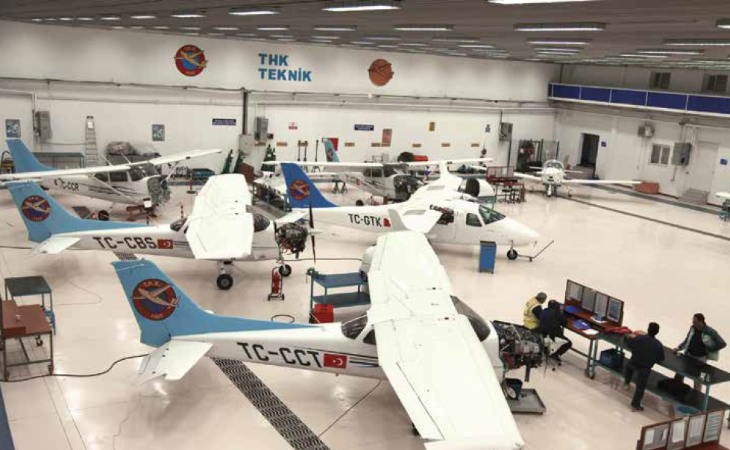
Figure ‎1.1: Training planes technical supports
The academic programs provided by Faculty of Engineering incorporate a variety of fields including aircraft electrical and electronics systems, autopilot design, avionics systems, control systems, composite material and machine manufacture, nanotechnology applications in aircrafts, alternative energy sources, power electronics, mobile applications, system design, simulation software, optimization problems, robotics and mechatronics applications and autonomous systems.
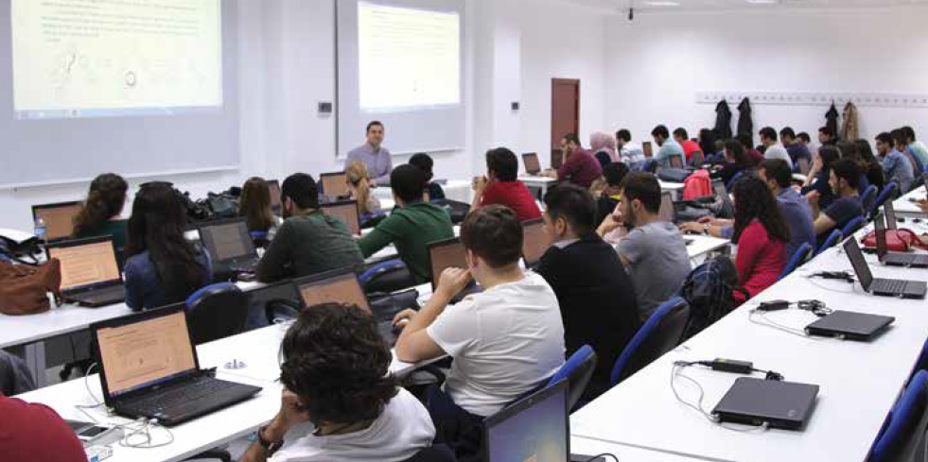
Figure ‎1.2: Computer aided design lab

Contributions and Novelties
Our contributions are as follows:
- There is no one who loves pain itself, who seeks after it and wants to have it, simply because it is pain
- There is no one who loves pain itself, who seeks after it and wants to have it, simply because it is pain
- There is no one who loves pain itself, who seeks after it and wants to have it, simply because it is pain

The Outline of the Thesis
In order to provide effective solutions to various problems in all areas of life, computer engineers are responsible for the tasks of analysis, design, implementation, testing and development of information systems that consist of computer hardware and software.
During their primary education, our students will also acquire expertise, according to their area of interests, on such topics as Fundamental Theories of Computer Science, Computer Hardware and Architecture, Software Engineering, Database Management Systems, Network and Wireless Communication, Parallel and Distributed Systems, Robotics, Security, Embedded Systems, Image Processing, Artificial Intelligence, and Data Mining.
In line with the technological developments, our students continue their study in the areas directly related to the aviation and space sciences that are the expertise fields of our university, besides their prominent work in hardware and software and will be able to satisfy the requirements of aviation industry in computer engineering field.

LITERATURE REVIEW
In order to provide effective solutions to various problems in all areas Electrical and Electronics Engineering is one of the most preferred professions, required in almost all technical fields at home and around the world because of the rapid growth in science and technology. Among the main objectives of the department is to allow students to develop necessary skills of defining, modelling, analyzing and solving engineering problems, designing and implementing an electronic system and its subcomponents, analyzing, interpreting and presenting the obtained results.

Introduction -(Heading 2)
We primarily aim to conduct education, research and industrial activities in the fields of electrical/electronics engineering and communication at a modern level of science and technology, thus raising qualified and research-oriented engineers that will utilize cutting edge electrical/electronic and computer technologies. Our university offers an opportunity to take courses from aeronautical and astronautical engineering and gives an opportunity to find a job in this area. The engineers graduated from this program will obtain the knowledge and engineering skills concerning wiredwireless communication systems, control command systems, robotics, automation, modelling and prototype development, simulation, real-time data reading evaluation, space robotics, remote sensing, ground and satellite systems, power electronics, high voltage, illumination and optics, mechanical and electronic stability.

Sample Figure- (Heading 3)
Our graduates will find the opportunity to work in civil and military electric-electronic-communication institutions and organizations, electronic defense industry, aircraft, automotive and biomedical sectors, energy production-transmission-distribution companies and in electromechanical industry.
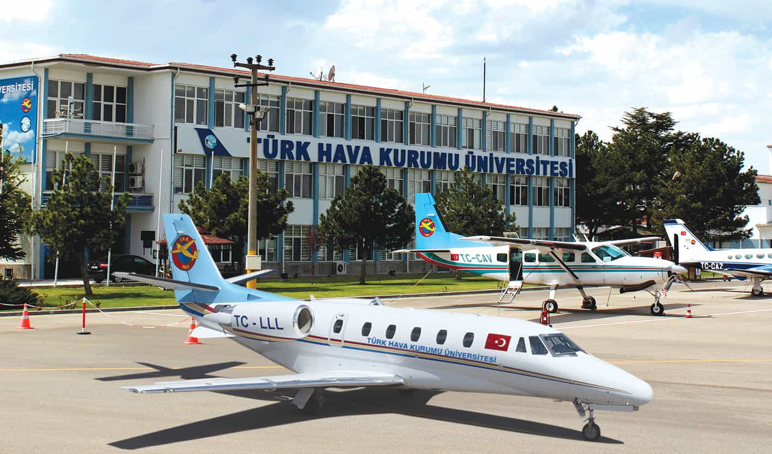
Figure ‎2.1: UTAA modern airplanes

Sample Equation- (Heading 3)
How the chemical, nuclear and electrical propulsion systems provide the necessary propulsion for launching and changing orbits of the space vehicles, is the answer for “Propulsion Systems”. “Control Systems” is about the solution of the problem for keeping a satellite or space vehicle in the desired orbit. Inspecting the effects of space environment on space systems and building space systems according to the these environment is the subject of the “Structural Systems”. Astronautical Engineers are able to gain expertise in one of these major fields by taking the elective courses.
$$y_{k}=∅_{k}\left(X\right)+x_{k}$$
$$y_{k}=x_{k}*P_{k}$$

Sample Table
Table ‎2.1: Results
Country List
Country Name or Area Name | ISO ALPHA 2 Code | ISO ALPHA 3 Code | ISO numeric Code
Afghanistan  Albania  Algeria  American Samoa  Andorra  Angola | AF  AL  DZ  AS  AD  AO | ALA  ALB  DZA  ASM  AND  AGO | 248  008  012  016  020  024

Create Sub-Section- (Heading 4)
Turkish Aeronautical Association aimed to become the center of production and training activities of aeronautical practices and went into action to transfer the years of intellectual knowledge to the academic basis in order to accomplish this goal.

CONCLUSION
Turkish Aeronautical Association aimed to become the center of production and training activities of aeronautical practices and went into action to transfer the years of intellectual knowledge to the academic basis in order to accomplish this goal. Turkish Aeronautical Association aimed to become the center of production and training activities of aeronautical practices and went into action to transfer the years of intellectual knowledge to the academic basis in order to accomplish this goal. A different Turkey, which can manufacture and export aircrafts as it used to do as well as remaining at the forefront of space research, was imagined and thought to be accomplished via a university that meets the increasing demand for qualified manpower and consists of the resources needed to support Research and Development.
Turkish Aeronautical Association aimed to become the center of production and training activities of aeronautical practices and went into action to transfer the years of intellectual knowledge to the academic basis in order to accomplish this goal. A different Turkey, which can manufacture and export aircrafts as it used to do as well as remaining at the forefront of space research, was imagined and thought to be accomplished via a university that meets the increasing demand for qualified manpower and consists of the resources needed to support Research and Development.

REFERENCES

[1] U. Erol, “Sample reference article,” METU Thesis Journal, vol. 2, no. 2, pp. 1–2, 2012.

[2] M. Latifinavid and E. ilhan Konukseven, “Hybrid model based on energy and experimental methods for parallel hexapod-robotic light abrasive grinding operations,” The International Journal of Advanced Manufacturing Technology, pp. 1–15, 2017.

[3] E. Brinksmeier, J. Aurich, E. Govekar, C. Heinzel, H.-W. Hoffmeister, F. Klocke, J. Peters, R. Rentsch, D. Stephenson, E. Uhlmann, et al., “Advances in modeling and simulation of grinding processes,” CIRP Annals-Manufacturing Technology, vol. 55, no. 2, pp. 667–696, 2006.

[4] R. I. King and R. S. Hahn, “Handbook of modern grinding technology,” Chapman and Hall, 29 West 35 th Street, New York, New York 10001, USA, 1986., 1986.

APPENDICES
- Appendix Title
Add appendix here

- Appendix Title
Add appendix here

- Appendix Title
Add appendix here

CURRICULUM VITAE (Only For Doctoral Thesis)
PERSONAL INFORMATION
Surname, Name: Faruk, Tülay
Nationality: Turkish (TC)
Date and Place of Birth: 1 April 1976, Ankara
Marital Status: Single
Phone: +90 312 589 64 33
Fax: +90 312 589 64 33
email: fbe@thk.edu.tr

EDUCATION
Degree | Institution | Year of Graduation
MS | UTAA Aeronautical Engineering | 1999
BS | UTAA Mechanical Engineering | 1996
High School | Atatürk Anadolu High School, Ankara | 1992

WORK EXPERIENCE
Year | Place | Enrollment
2003-Present | KLAN Mühendislik | Control Chief
1997-2003 | UTAA Dept. of Mechanical Eng. | Research Assistant
1995 July | FMC Nurol | Intern Eng. Student
1994 August | Arçelik | Intern Eng. Student

FOREIGN LANGUAGES
Advanced English, Fluent German
PUBLICATIONS
1. Eryaman Y., Savucu S. and Mert M. "Model Predictive Control of a CSTR for Boric Acid Production", Control Journal, 5(12), 225-228 (2004)
2. Eryaman Y., Mert M. "Borik Asit Üretilen Bir Karıştırmalı Tepkime Kabının Model Öngörülen Denetim", TÜBİTAK DOĞA Dergisi, 12(3), 121-125 (2003)
Tennis, Scuba, Gourmet, Computer Technologies, Movies, Motor Sports

